Iterative Time Complexity

- Past Question - CSE221_SolutionOfPastQuestions_TimeComplexity [Student View]

- Open DSA - 4.6. Calculating Program Running Time — CS2 Software Design & Data Structures

- Princeton - COS226 A-nalysis of Algorithms: Practice Examples Spring ‘20

- UNSW - COMP 9024, Homework Solution, 11s2, Class 1

- UMBC - CMSC 441: Homework #1 Solutions

- NUS - Tutorial 9 – Analysis of Algorithms 1. Big-O Complexity

- HFN - 1.3 time complexity Additional Solution and prep.pdf

- Examples shown in class - Iterative Time Complexity Examples
- ANK - Practice sheet time complexity

Previous Midterm Questions

1.
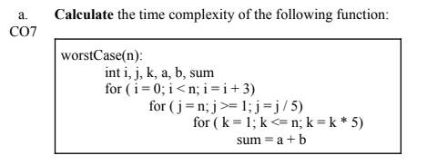
2.
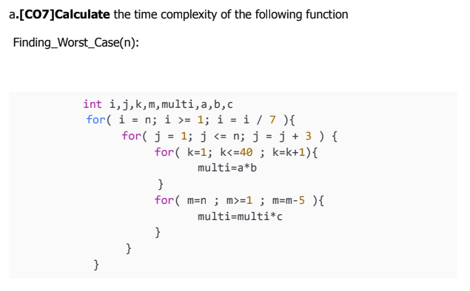

3.
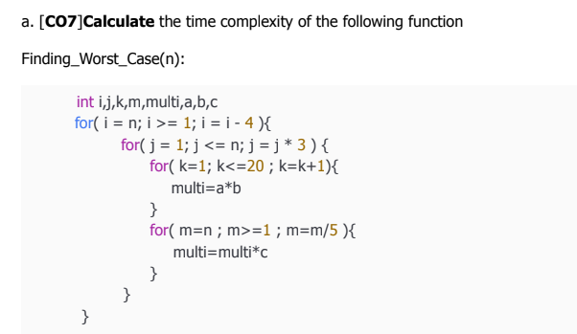
4.
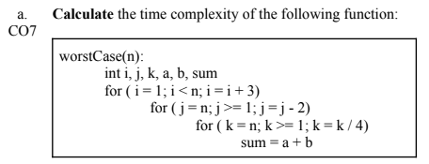

5.
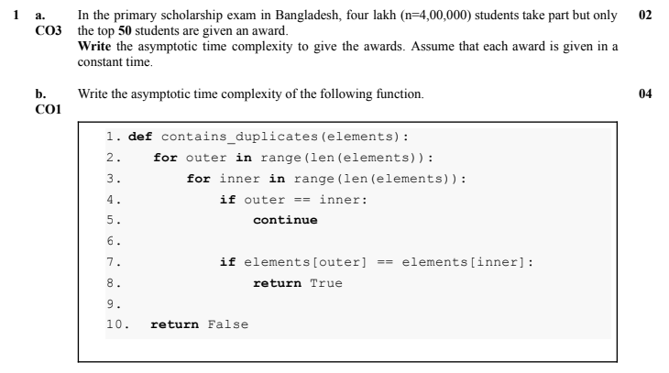
6.
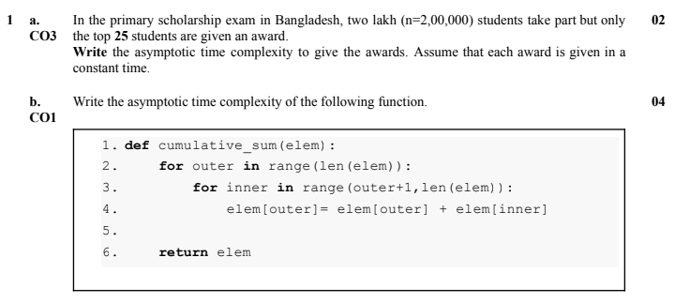

7.
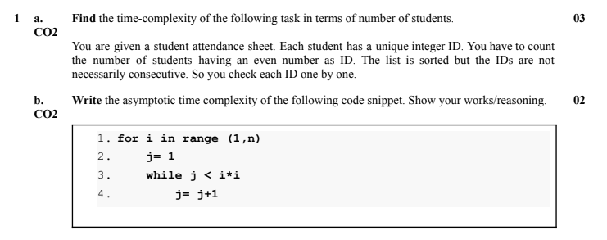
8.
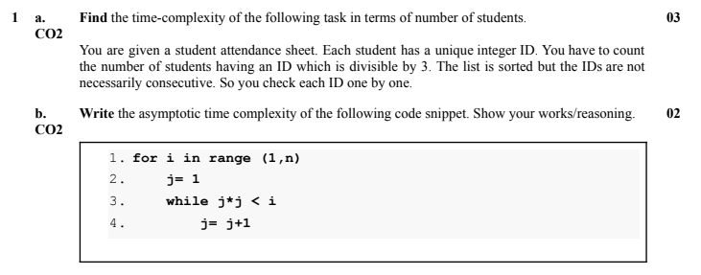

9.
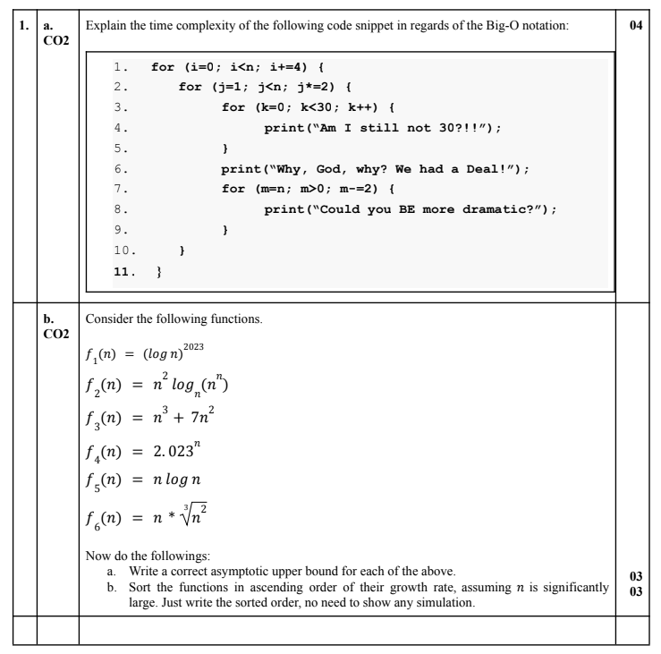

10.
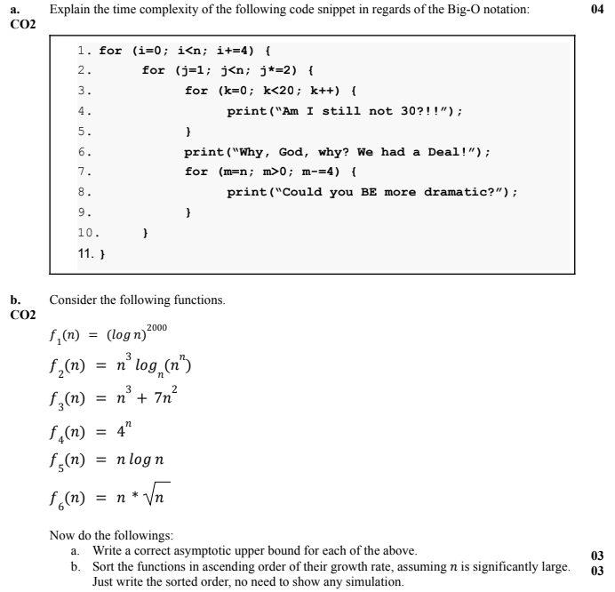

11.
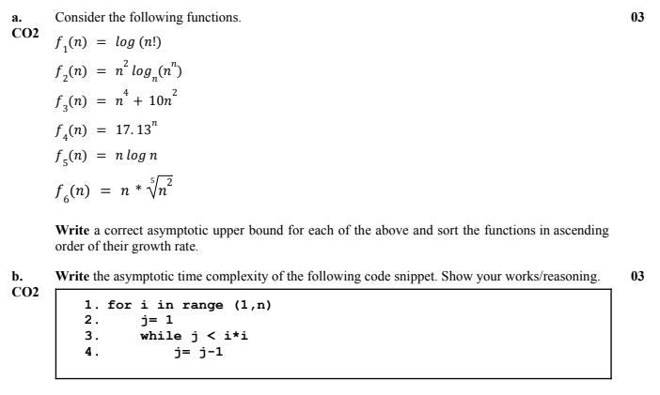
12.
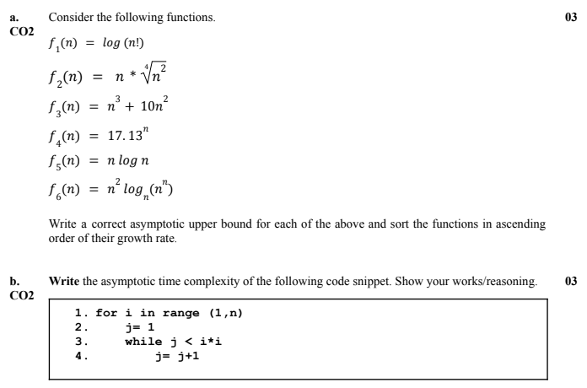
13.
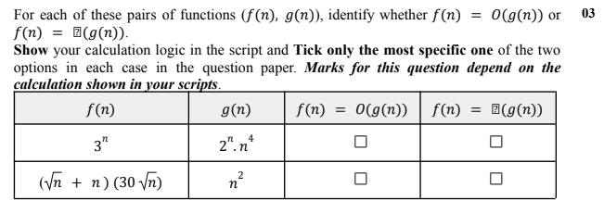
14.
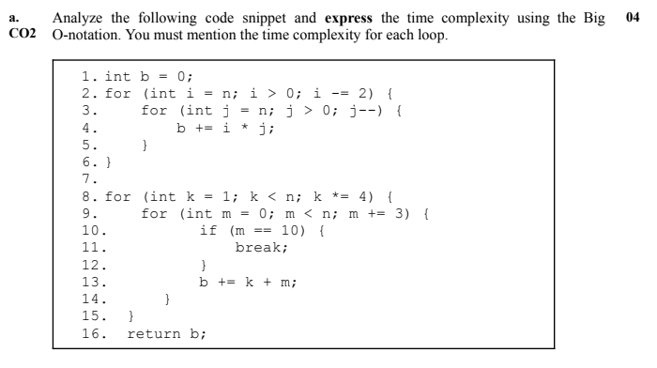

15.
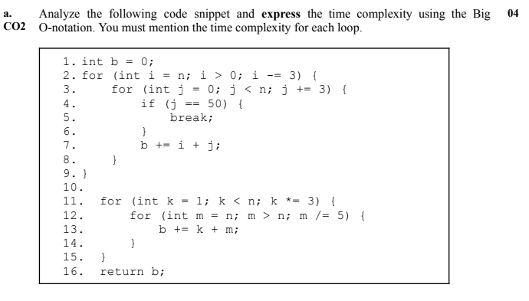

16.
